**LAB 14**

**14.1Using the following UML diagram, create the “Student” class and define and declare all necessary data members and member functions. Then use main function to call these member functions**

**SOURCE CODE**

**#include <iostream>**

**using namespace std;**

**class student**

**{**

**public:**

**string name;**

**char grade;**

**public:**

**void getname()**

**{**

**cout << "Enter your name: ";**

**cin >> name;**

**cout << "\nEnter your grade: ";**

**cin >> grade;**

**}**

**void printgrade()**

**{**

**cout << "\nThe grade of " << name << " is " << grade << endl;**

**}**

**};**

**int main()**

**{**

**student s; //creating objects**

**s.getname();**

**s.printgrade();**

**return 0;**

**}**

**OUTPUT**

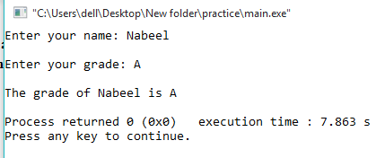

**14.2 Write a program to perform an inheritance any of your choice.**

**SOURCE CODE**

**#include <bits/stdc++.h>**

**using namespace std;**

**//Base class**

**class Parent**

**{**

**public:**

**int id_p;**

**};**

**// Sub class inheriting from Base Class(Parent)**

**class Child : public Parent**

**{**

**public:**

**int id_c;**

**};**

**//main function**

**int main()**

**{**

**Child obj1;**

**// An object of class child has all data members**

**// and member functions of class parent**

**obj1.id_c = 66;**

**obj1.id_p = 77;**

**cout << "Child id is " << obj1.id_c << endl;**

**cout << "Parent id is " << obj1.id_p << endl;**

**return 0;**

**}**

**OUTPUT**

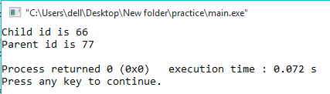

**14.3 Write C++ program to create class to read time in HH:MM:SS format and display into seconds**

**SOURCE CODE**

**#include <iostream>**

**#include <iomanip>**

**using namespace std;**

**class Time**

**{**

**private:**

**int seconds;**

**int hh,mm,ss;**

**public:**

**void getTime();**

**void convertIntoSeconds();**

**void displayTime();**

**};**

**void Time::getTime()**

**{**

**cout << "Enter time:" << endl;**

**cout << "Hours? "; cin >> hh;**

**cout << "Minutes? "; cin >> mm;**

**cout << "Seconds? "; cin >> ss;**

**}**

**void Time::convertIntoSeconds()**

**{**

**seconds = hh*3600 + mm*60 + ss;**

**}**

**void Time::displayTime()**

**{**

**cout << "The time is = " << setw(2) << setfill('0') << hh << ":"**

**<< setw(2) << setfill('0') << mm << ":"**

**<< setw(2) << setfill('0') << ss << endl;**

**cout << "Time in total seconds: " << seconds;**

**}**

**int main()**

**{**

**Time T; //creating objects**

**T.getTime();**

**T.convertIntoSeconds();**

**T.displayTime();**

**return 0;**

**}**

**OUTPUT**

